Date: July 6, 2010

uptime Solutions Services

Realtime Metrics Graphing



**© 2009 uptime software inc.**

# Table of Contents

Table of Contents 2

Revision History 3

Notes 3

Introduction 4

How It Works 5

Files 5

Requirements 6

Installation 6

Testing 7

Upgrading 8

Troubleshooting 8

Setting the Graphs to Debug Mode 8

# Revision History

|  |  |  |  |
| --- | --- | --- | --- |
| **Rev** | **Date** | **Author** | **Description** |
| 1 | July 6, 2010 | Joel Pereira | Initial creation |

# Notes

N/A

# Introduction

This document provides information on the Realtime Graphing module capabilities provided by uptime software. The realtime graph is accessed by a new button on the top-right of the “Quick Snapshot” link in the graphing section of a system added to up.time. The button is named “Real Time View”.

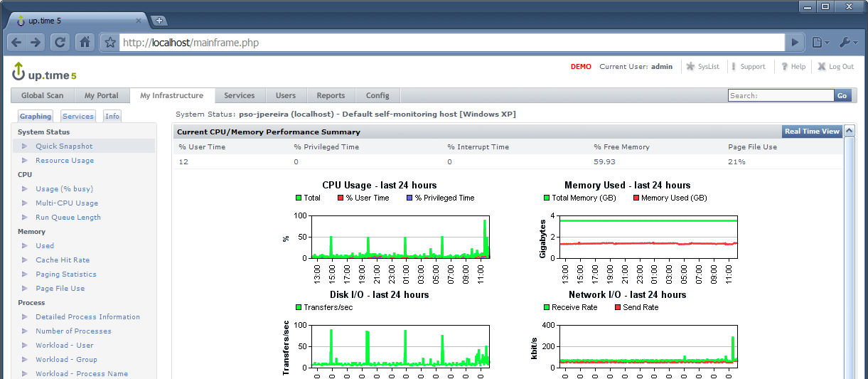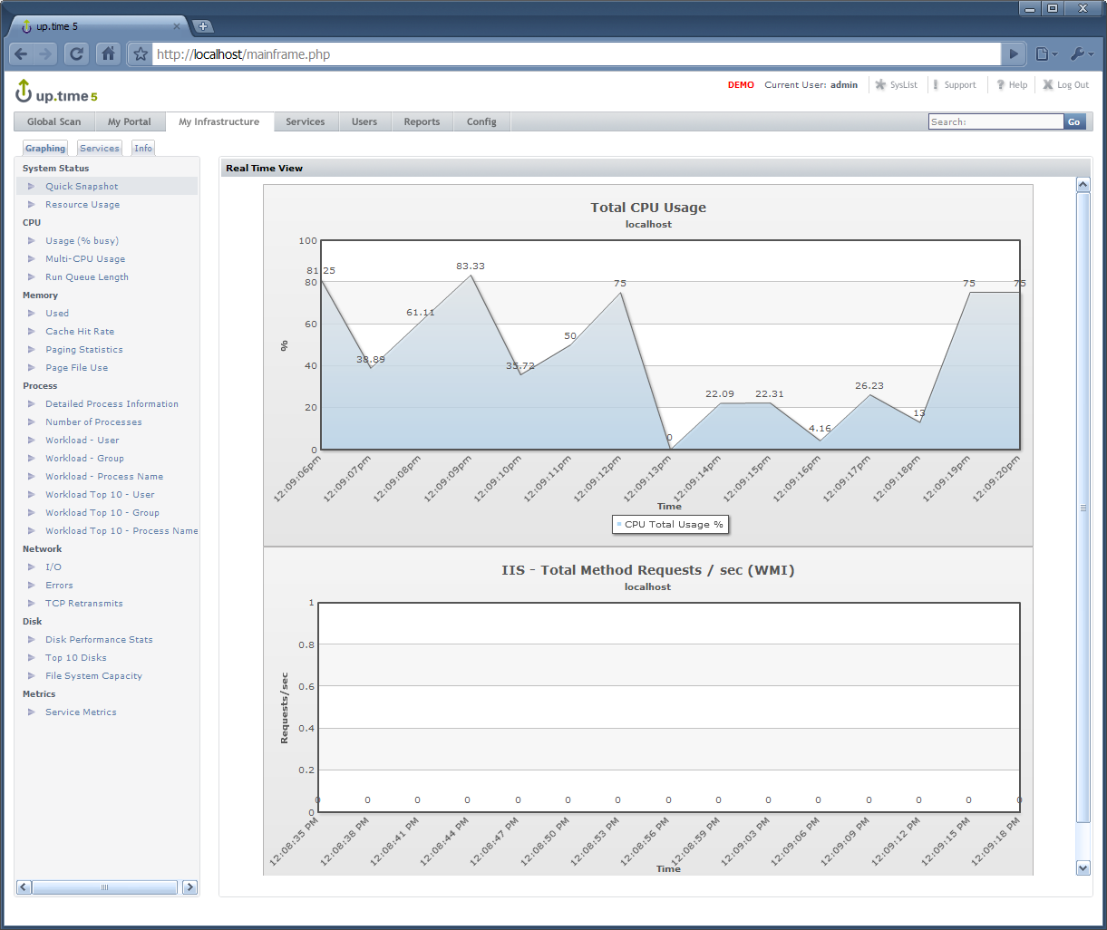

# How It Works

There are a few main components for the realtime graphs. We use FusionWidgets (from <http://www.fusioncharts.com/widgets/docs/>) to generate the realtime graphs with the documented “dataURL Method using JavaScript class“ of retrieving the metrics. For further info please read the docs.

We load a webpage (rt-ui.php) defining the FusionWidget with the settings loaded from XML output generated from the dataURL. This XML description page (rt-xml-desc.php) is dynamically generated based on the “GET” variables that are sent to it from the main UI page. The FusionChart will then retrieve data from the “datastreamURL” (rt-out.php or rt-wmi.php) returned from the XML description page on the defined refresh interval (normally every second). This datastream page will gather the metrics via the up.time agent or WMI and output it in a specific text format for the chart to load the metric(s). This datastream page is accessed every second (or few seconds) so it must load the data quickly.



# Files

All files are in one subdirectory named “realtime” in “<uptime_dir>/GUI/”. There is one directory named “FusionWidgets” that contain all the compiled graphing widgets (in Flash). None of these should ever need to be changed for real-time graphing to function.

The following is the list of files/directory(s) that are included in this package:

|  |  |
| --- | --- |
| **File/Dir** | **Description** |
| FusionWidgets (directory) | Contains all the FusionWidgets Flash files |
| rt-ui.php | The first page that displays the realtime page & graphs |
| rt-xml-desc.php | Dynamically generates the XML description for the FusionWidgets based on the HTTP GET variables sent to it |
| rt-out.php | Page that connects to the agent and returns metrics in a format that FusionWidgets can digest |
| rt-wmi.php | Page that triggers the execution of a vbs (WMI) script |
| iis_method_requests_per_sec.vbs | The vbs script that gets its data via WMI |

# Requirements

For the realtime graphs to function they require the following:

* Installed on a Windows up.time monitoring station (or at least a Windows Apache build with PHP)
* Currently the agent data requires an up.time agent on each of the remote systems to get performance data

# Installation

Installation is easy.

1. Extract the zip file into the “<uptime_dir>/GUI/” directory and that’s it. It will create a directory named “realtime” with all the files in there.

Folder Structure:

<uptime_dir>/GUI/realtime/*

1. Now in the up.time monitoring station interface, click on the “Config” tab and click on “up.time Configuration” on the left side menu.
   * If you do not see a “Config” tab you will need to login as a user that has “superadmin” role access.
2. In the textbox enter the following on a new line:

realtime.view.enabled=true

realtime.view.URL=http://UPTIME-HOST/realtime/rt-ui.php?

Make sure to change “UPTIME-HOST” to the proper hostname of the system where the files are located. If the web server is running on a port other than “80”, just enter the port information in the URL in the following format: “http://UPTIME-HOST:9999/realtime/rt-ui.php?”

For example, if the files are on the same system as your up.time install, and the hostname of the system is “uptime01”, the line would read:

realtime.view.URL=http://uptime01/realtime/rt-ui.php?

1. Now navigate to the “Graphing” section of an agent system in up.time and click on the “Quick Snapshot” section. You should now see a “Real Time View” button

# Testing

Since the realtime graphs are now fully detached from the up.time monitoring station, they can be used to graph realtime stats from systems that are not added to up.time. The only requirements for the graphs to work are:

* Have an up.time agent installed (for the first graph)
* Have IIS installed (for the second graph)

To test if the realtime graphs are working properly:

1. Open up a browser and enter the following URL:
   * http://UPTIME-HOST/realtime/rt-ui.php?hostname=REMOTE-HOST&port=9998&ssl=false
   * Change the “REMOTE-HOST” to a hostname of a system you want to test realtime for.

You should see two graphs like the following:

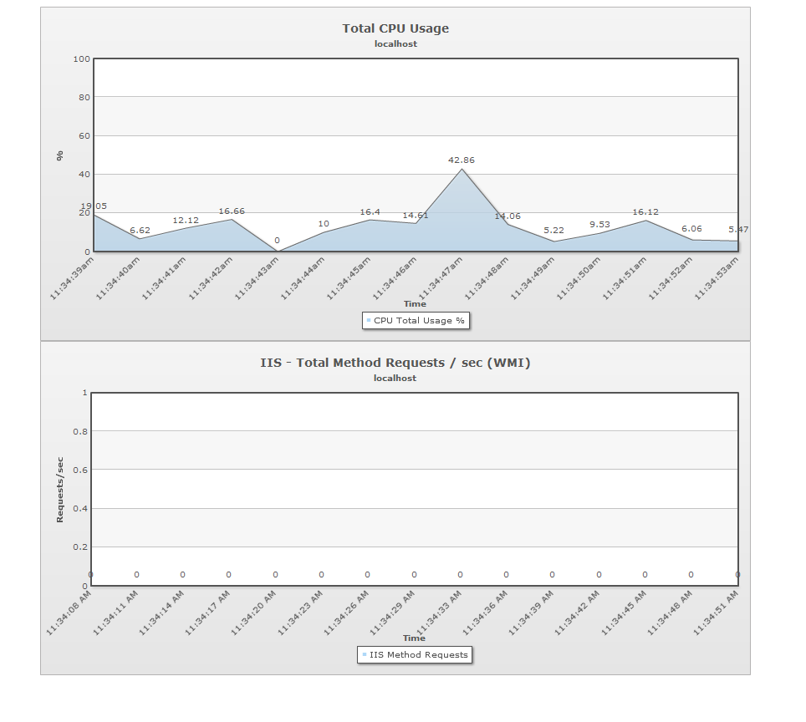

# Upgrading

Upgrading simply involves replacing the old files with the new files. The best way to upgrade is to:

1. Rename/move the original directory “<uptime_dir>/GUI/realtime” to “<uptime_dir>/GUI/realtime_old”
2. Extract the new zip file into the “<uptime_dir>/GUI” directory.
3. Check if anything else needs to be done with the updated documention.
4. Test the new realtime graphs using the “Testing” section in this document.

# Troubleshooting

If the realtime graphs are not working there may be different reasons depending on the different symptoms. If the graphs are not working, the first thing to do is to set the page into Debug mode. For more info on how to do this, go to the “Setting the Graphs to Debug Mode” section below.

## Setting the Graphs to Debug Mode

When there is a problem with the realtime graphs, the best way is to set the graphs to debug mode. Debug mode allows the graphs to display more verbose information so we can figure out what is causing the issue.

To set the graphs to debug mode:

1. Open the “rt-ui.php” page in a text editor
2. Modify the line at the top from:

$debug = 0;

to:

$debug = 1;

Now when you access the page it will have debug information displayed that is useful for us to determine what the issue may be. It will look similar to the following:

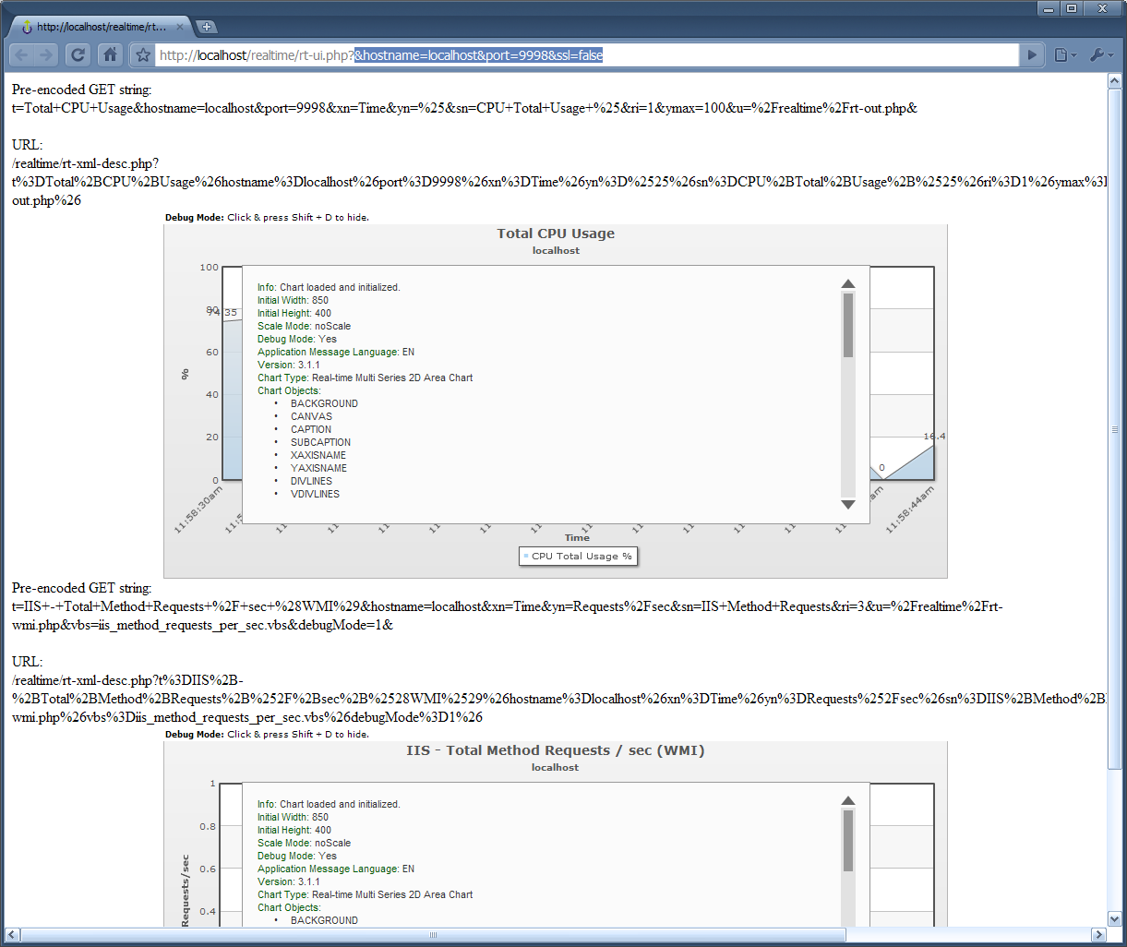

The text above the graphs show what the generated URL for the XML description page will look like. If it is not formatted properly, the graph may not work, so with that output we can verify the contents.

The graphs themselves will also display a lot more detailed data on them as well. To enable/disable the debug output on the graphs, just click anywhere in the graph area and click “shift+D”.

For more info on FusionWidgets documention click on the link below:

<http://www.fusioncharts.com/widgets/docs/>

An important thing to note is that each page (rt-ui.php, rt-out.php, rt-wmi.php) has it’s own “debug” variable that can be set to output more information at each level so we can further troubleshoot the issue.